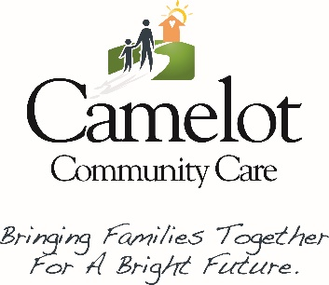

FOSTER HOME RECRUITMENT & LICENSING SPECIALIST
POSITION ANNOUNCEMENT

Camelot Community Care is currently recruiting for a Foster Home Recruitment and Licensing Specialist in our Palm Beach/Treasure Coast Office.

SUMMARY
This position is responsible for the recruitment, training, licensing and support of foster homes in various programs.

ESSENTIAL DUTIES AND RESPONSIBILITIES include the following. Other duties may be assigned.
1) Recruits foster homes on an on-going basis according to programmatic and contractual requirements resulting in licensed homes to adequately meet the placement needs of the program.
2) Successfully retains licensed foster homes through providing on-going support to foster parents.
3) Conducts foster home visits as required by contract or as assigned by the program supervisor and evaluates the home and family for continued compliance with licensing standards as well as assessing whether appropriate care is being provided in the home.
4) Completes the home study and other assessment documents thoroughly to include an in-depth review of the potential family’s appropriateness to be a foster parent.
5) Completes initial licensing packets according to contractual, programmatic and regulatory requirements.
6) Completes all re-licensing packets according to contractual, programmatic and regulatory requirements.
7) Responds to all foster parent inquiries on a timely basis.
8) Conducts or participates in regularly scheduled new foster parent orientation sessions.
9) Conducts or participates in all required pre-service and on-going training of foster parents according to contractual, programmatic and regulatory requirements.
10) Maintains accurate foster parent licensing files, monthly activities/status reports and records regarding licensing status of each foster home.
11) Attends all required meetings held by the program, funders and contractors.
12) Assists with the placement of foster children. Coordinates respite for foster/adoptive families and assists in identifying alternative placements for children that experience a planned or unplanned disruption.
13) Maintains accurate records in all required databases and reporting systems required by Camelot Community Care or its funders.

SUPERVISORY RESPONSIBILITIES
This position does not supervise any staff

QUALIFICATIONS
To perform this job successfully, an individual must be able to perform each essential duty satisfactorily. The requirements listed below are representative of the knowledge, skill, and/or ability required. Reasonable accommodations may be made to enable individuals with disabilities to perform the essential functions.

Interested candidates should send a resume to Leslie Serena, Regional Executive Director via email to: lserena@camelotcommunitycare.org by August 30, 2021 for immediate consideration. EOE

