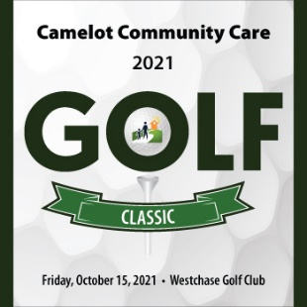
2021 Camelot Community Care Golf Classic
Silent Auction Donation Information Sheet

Person donating item:_______________________________________________________

Name of Company: _________________________________________________________

Company Address: _________________________________________________________

City: ______________________ State: ___________ Zip: __________________

Phone Number: __________________ Email Address: ________________________

Item Name: ______________________________________________________________

Item Description: _________________________________________________________________________

Item Restrictions: __________________________________________________________

_________________________________________________________________________

Estimated Retail Value: _____________________________________________________

Additional Information: ___________________________________________________________________________________________________________________________________________________________________________________________________________________________

Please return this form via mail or email to by Wednesday, September 29, 2021:
Rebecca Payne - CDO
Camelot Community Care
4910-D Creekside Drive, Clearwater, FL 33760
727-593-0003 Ext. 30124 – rpayne@camelotcommunitycare.org
-------------------------------------------------------------------------------------------------------------------------------------------------------
For Office Use Only:
Received by: _____________________________________ Date: _____________________________

